

***DELL FSD - Learner’s Academy Project***

***By***

***Prasanth Chandrasekar***

***TABLE OF CONTENTS***

|  |  |  |
| --- | --- | --- |
| **S.No** | **Content** | **Page Number** |
| **1** | **Problem Statement** | **3** |
| **2** | **Sprints and the User Stories** | **3** |
| **3** | **Jira User Story** | **5** |
| **4** | **Jira Sprint** | **5** |
| **5** | **Tools used in the project** | **6** |
| **6** | **Hierarchy of Codes** | **6** |
| **7** | **Application Architecture / Flow Chart** | **7** |
| **8** | **Exception Handling** | **8** |
| **9** | **Entity Relationship Diagram** | **8** |
| **10** | **Entity and Tables** | **9** |
| **11** | **Tables Created in Database** | **9** |
| **12** | **Project requirement** | **10** |
| **13** | **Screenshots showing completion of Project requirement** | **10** |
| **14** | **Git Screenshots** | **14** |
| **15** | **GitHub Screenshots** | **15** |
| **16** | **GitHub Repository Link for source Code and other Project related Files** | **16** |

***Problem Statement:***

Learner’s Academy is a school that has an online management system. The system keeps track of its classes, subjects, students, and teachers. It has a back-office application, The administrator can:

* Set up a master list of all the subjects for all the classes
* Set up a master list of all the teachers
* Set up a master list of all the classes
* Assign classes for subjects from the master list
* Assign teachers to a class for a subject (A teacher can be assigned to different classes for different subjects)
* Get a master list of students (Each student must be assigned to a single class)

There will be an option to view a Class Report which will show all the information about the class, such as the list of students, subjects, and teachers

The goal of the company is to deliver a high-end quality product as early as possible.

***Sprints and the User Stories:***

***Sprint-1: (One week)***

* **User Story-1** : As an Administrator, I want to have an option to create Students, so that i can set up a master list of Students
* **User Story-2 :** As an Administrator, I want to have an option to create Subjects, so that i can set up a master list of Subjects
* **User Story-3** : As an Administrator, I want to have an option to create Classes, so that i can set up a master list of Classes
* **User Story-4** : As an Administrator, I want to have an option to create Teachers, so that i can set up a master list of Teachers
* **User Story-5** : As an Administrator, I want to have an option to view Students, so that i can view a Student by Id and also a list of Students.
* **User Story-6 :** As an Administrator, I want to have an option to view Subjects, so that i can view a Subject by Id and also a list of Subjects.
* **User Story-7** : As an Administrator, I want to have an option to view Classes, so that i can view a Class by Id and also a list of Classes.
* **User Story-8** : As an Administrator, I want to have an option to view Teachers, so that i can view a Teacher by Id and also a list of Teacher.
* **User Story-9** : As an Administrator, I want to have an option to update Students, so that i can modify a Student by Id.
* **User Story-10** : As an Administrator, I want to have an option to update Subjects, so that i can modify a Subject by Id.
* **User Story-11** : As an Administrator, I want to have an option to update Classes, so that i can modify a Class by Id.
* **User Story-12** : As an Administrator, I want to have an option to update Teachers, so that i can modify a Teacher by Id.

***Sprint-2:(one week)***

* **User Story-1** : As an Administrator, I want to have an option to delete Students, so that i can remove Students whenever they are off-boarded.
* **User Story-2** : As an Administrator, I want to have an option to delete Subjects, so that i can remove Subjects whenever they are not required.
* **User Story-3** : As an Administrator, I want to have an option to delete Classes, so that i can remove Classes whenever they are not required.
* **User Story-4** : As an Administrator, I want to have an option to delete Teachers, so that i can remove Teachers whenever they are off-boarded.
* **User Story-5** : As an Administrator, I want to have an option to assign Students to Classes, so that i can assign Students to Classes whenever the students are promoted or on-boarded.
* **User Story-6** : As an Administrator, I want to have an option to assign Subjects to Classes, so that i can have subjects assigned to Class.
* **User Story-7** : As an Administrator, I want to have an option to assign Subjects to Teachers, so that i can assign Teachers to Subjects.
* **User Story-8** : As an Administrator, I want to have an option to assign Teachers to Classes, so that i can assign Teachers to Classes.:

***Jira User Story – Agile Scrum :***

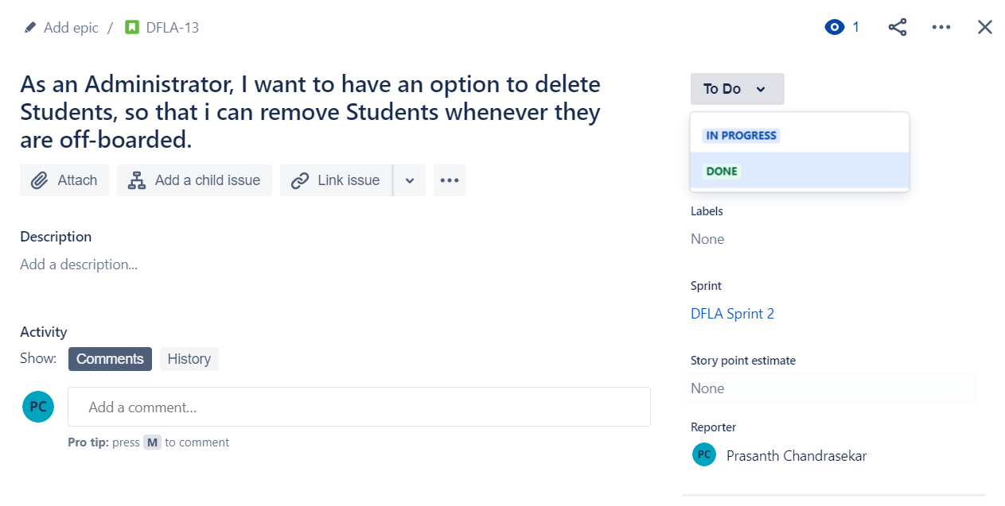

***Jira Sprint– Agile Scrum :***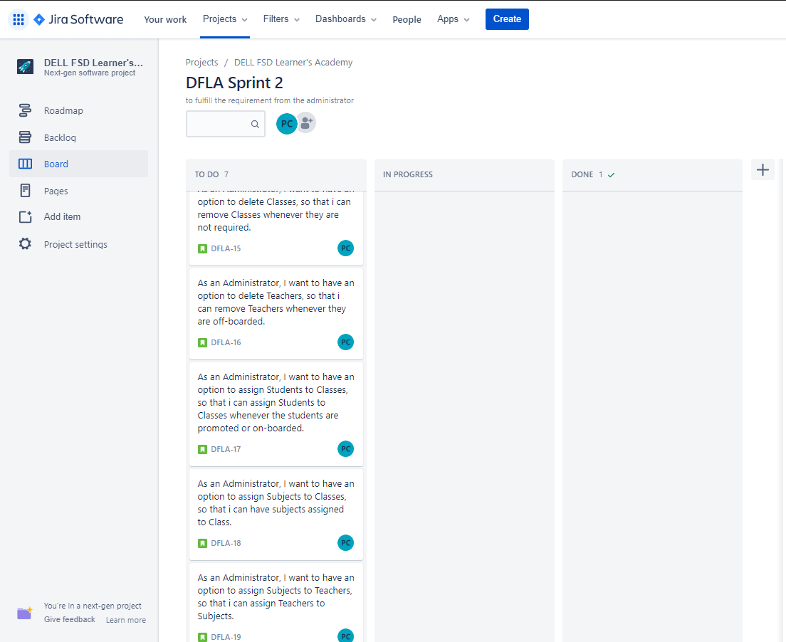

***Tools used in the Project:***

|  |  |
| --- | --- |
| ***Programming Language and related*** | ***Java, Hibernate, Jersey, Angular, TypeScript, html, css, bootstrap*** |
| ***IDE*** | ***Eclipse, Microsoft Visual Code*** |
| ***SQL*** | ***MySQL*** |
| ***Version Control System*** | ***Git & GitHub*** |
| ***Software Development Methodology*** | ***Agile - Scrum - Jira*** |

***Hierarchy of codes developed:***

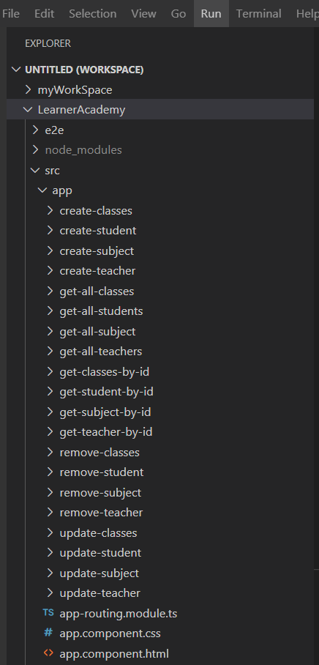 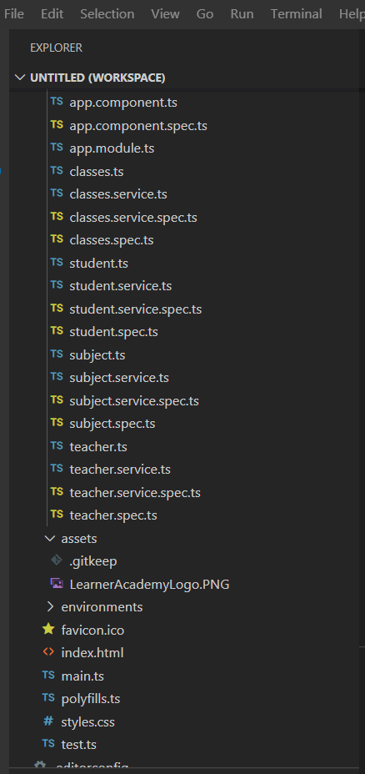

**Application Architecture and Flow Chart (Back-End):**

**In Front-End architecture, the Postman Client is replaced with a Browser.**

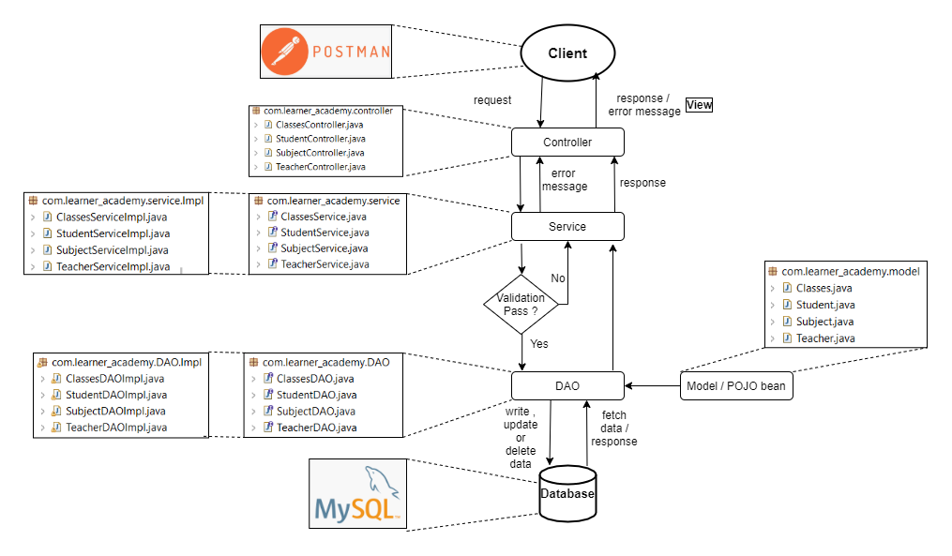

***Exception Handling:***

Some of the exceptions and errors are handled, so that the application won’t close, exit or throw an exception.

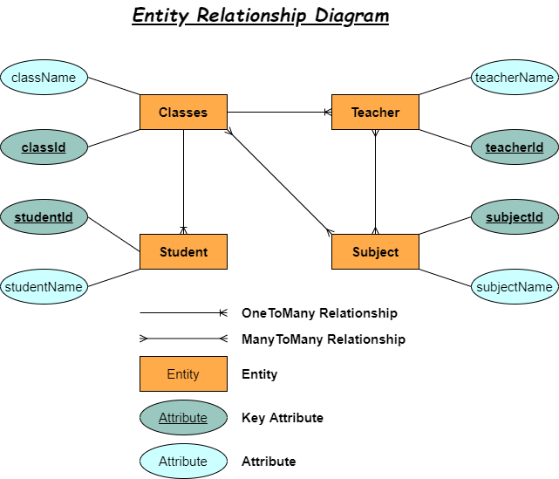

***Entity and Tables:***

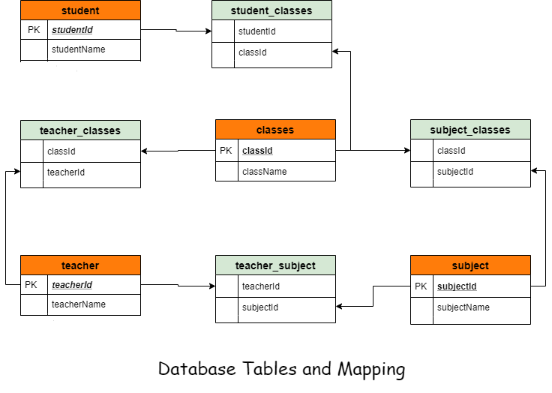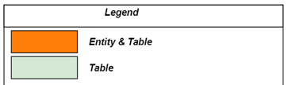

***Tables created in Database:***

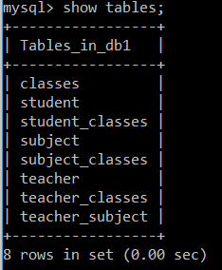

***Project Requirement:***

|  |  |
| --- | --- |
| **Project Requirement** | |
| **S.No.** | **Requirement** |
| 1 | Set up a master list of all the subjects |
| 2 | Set up a master list of all the teachers |
| 3 | Set up a master list of all the classes |
| 4 | Assign subject for class |
| 5 | Assign teacher to subject |
| 6 | Get a master list of students |
| 7 | An option to view a Class Report which will show all the information about the class, such as the list of students, subjects, and teachers |

***Screenshots taken while executing project requirements and their verification:***

1. ***Set up a master list of all the subjects:***

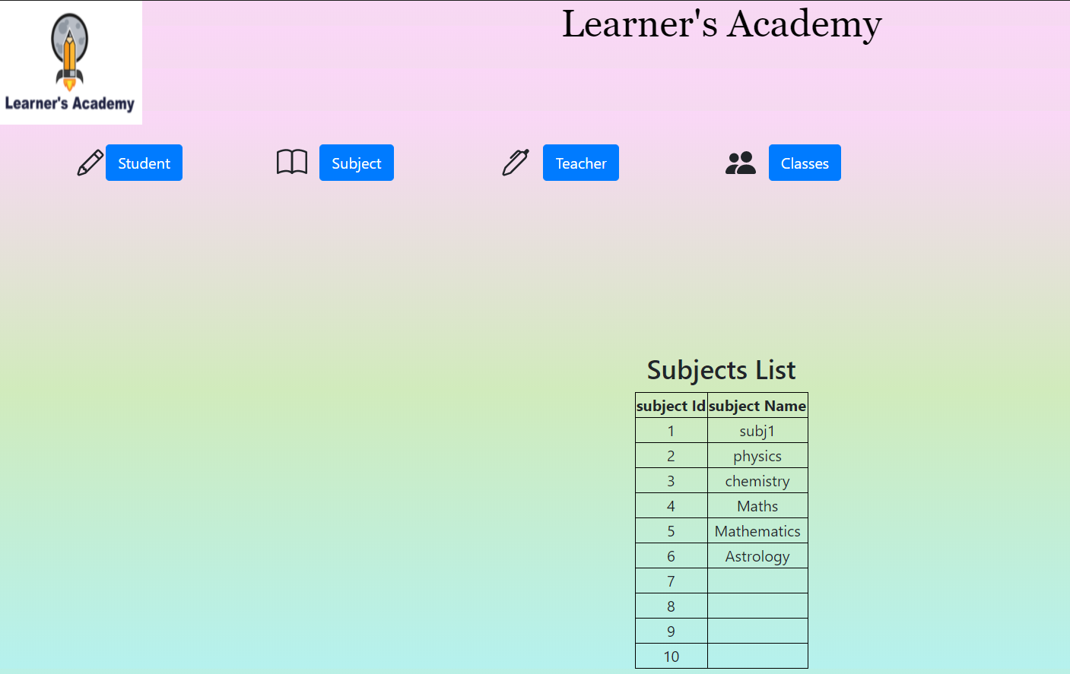

1. ***Set up a master list of all the teachers:***

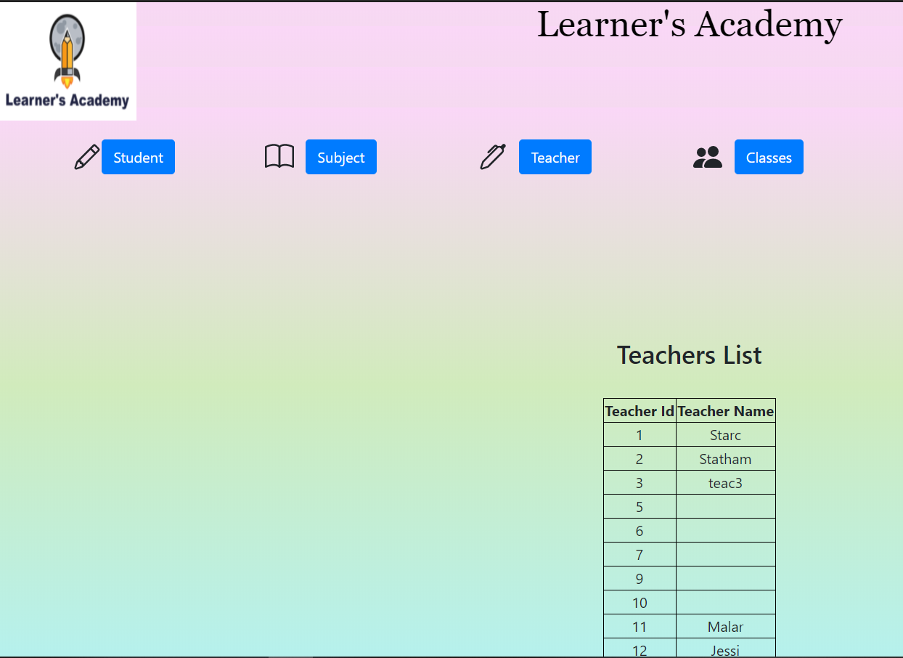

1. ***Set up a master list of all the classes:***

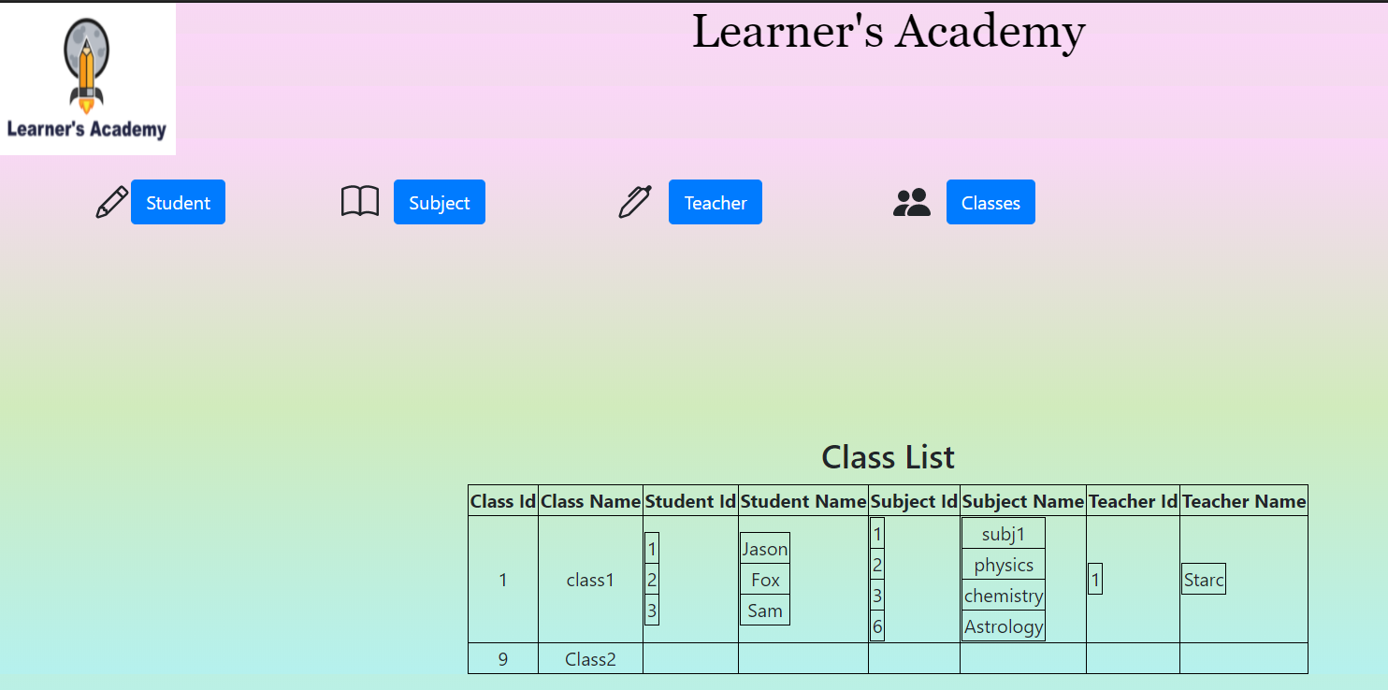

1. ***Assign subject for class:***

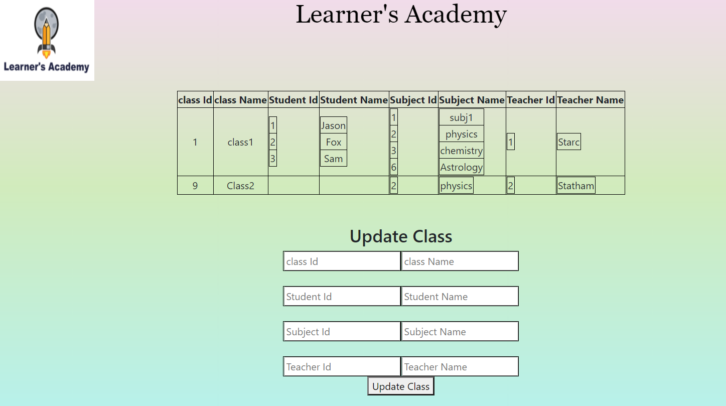

1. ***Assign teacher to subject:***



1. ***Get a master list of students***

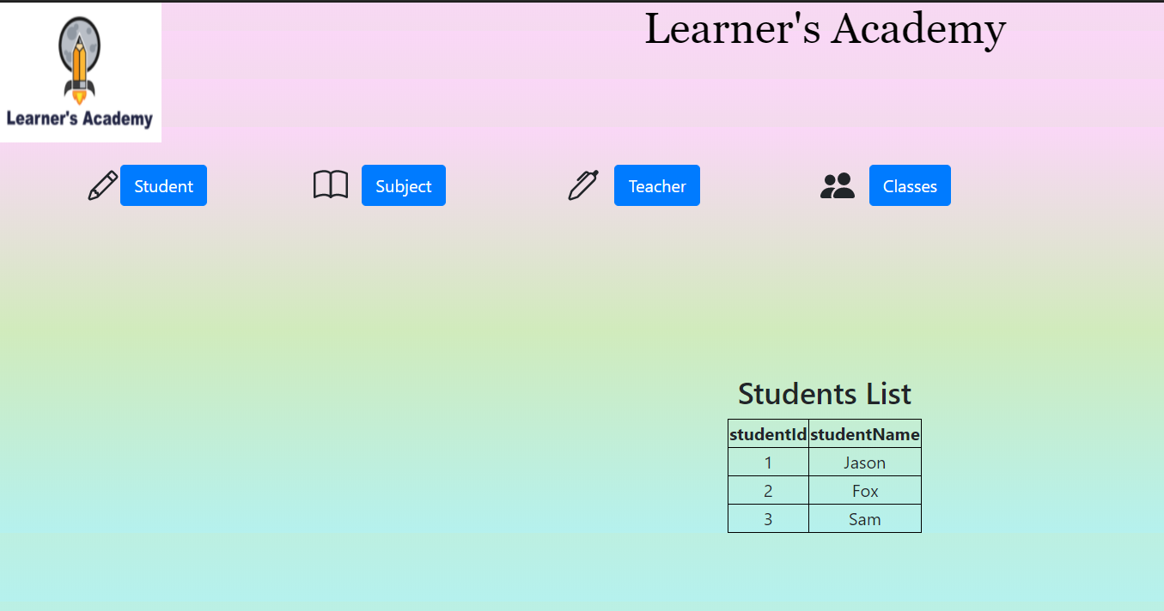

1. ***An option to view a Class Report which will show all the information about the class, such as the list of students, subjects, and teachers:***

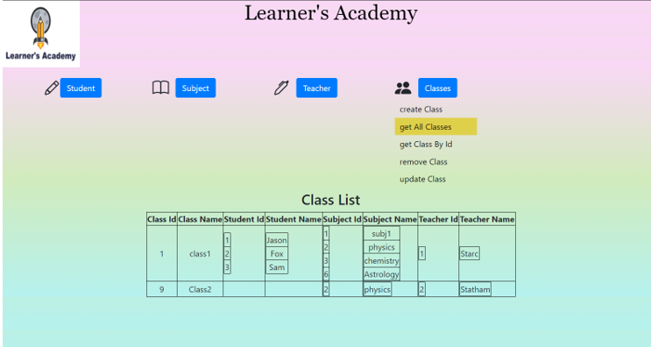

***Git Screenshots:***

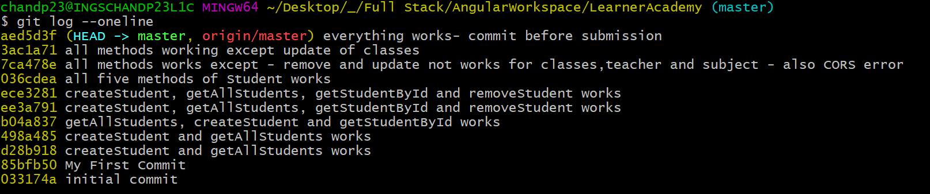

***GitHub Screenshot:***

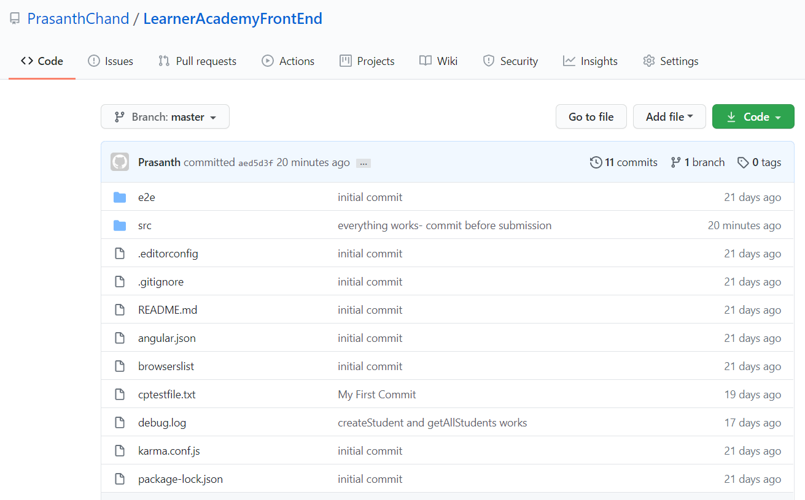

***GitHub Repository:***

***All the project related files are uploaded to the below GitHub repository.***

***Note: The data in the database might be different from the screenshots, as few data were modified for testing purpose after taking screenshot. This project specification document is uploaded to below GitHub Repository in both .doc and .pdf extensions.***

**Front End related codes :** <https://github.com/PrasanthChand/LearnerAcademyFrontEnd>

**Back End related codes :** <https://github.com/PrasanthChand/LearnerAcademy>